Linux Commands End to End Cheat Sheet

whoami – command is used to check who is the current user
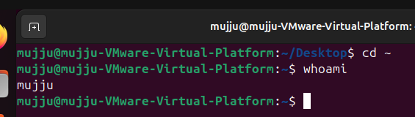

ls – list of files
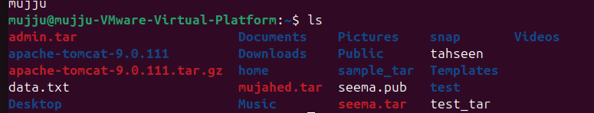

Ip a - shows Ip address and network interfaces
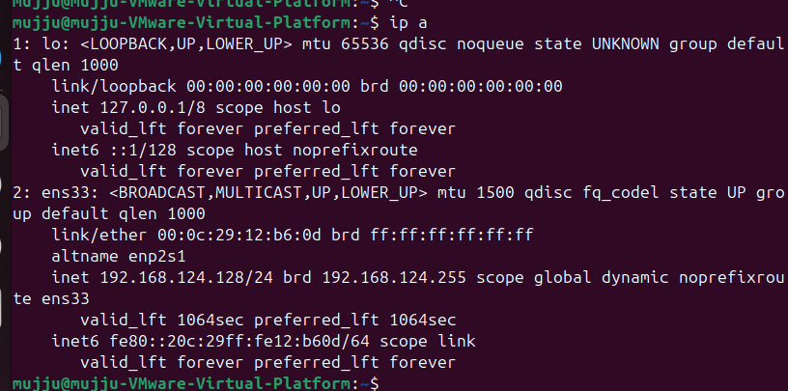

touch command is used for creating a file with zero byte and cat to read the content in the file
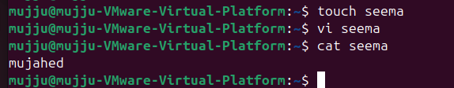

Passwd – used to create and change passwd
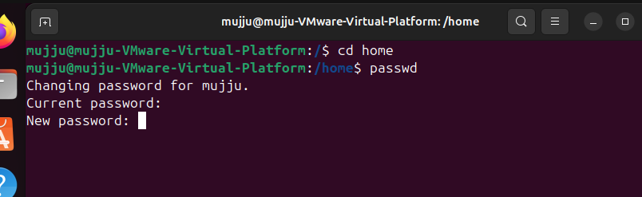

Pwd – present working directory
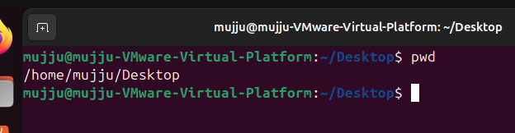

man command is used to check all the alternatives of command
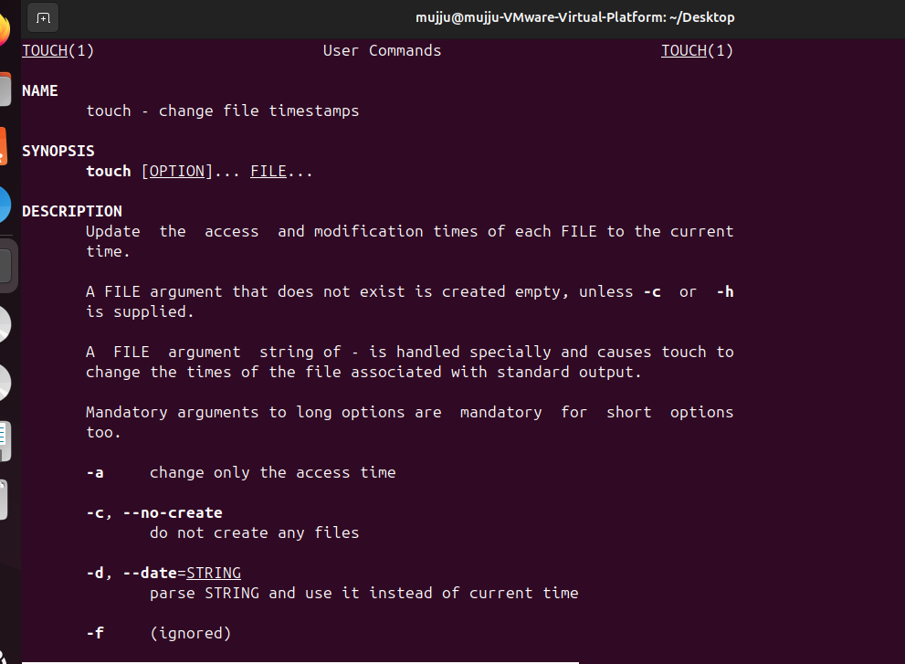

Apropos -Searches commands related to a specific task based on description
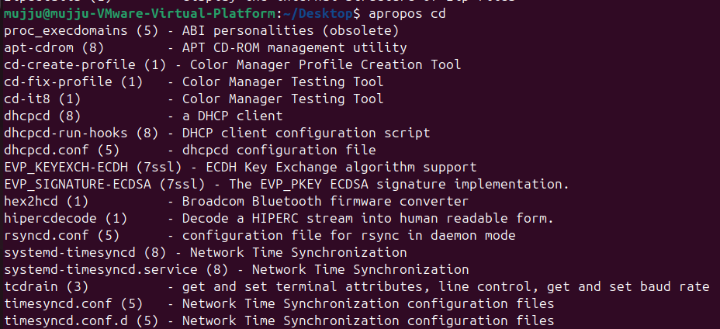

pinfo – provides additional information about the command
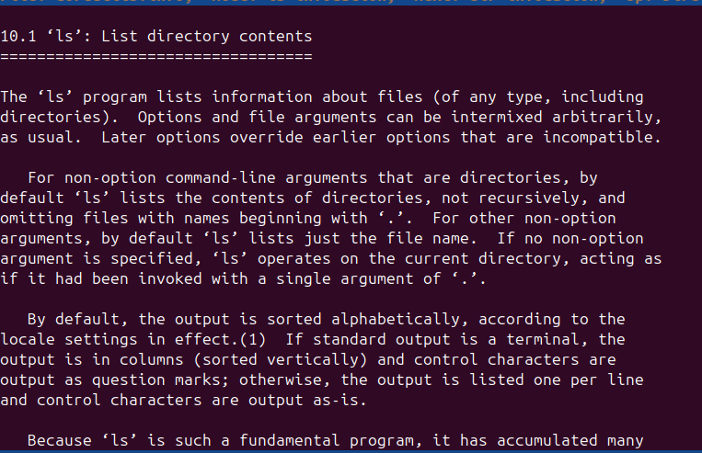

tldr – simplified version of man
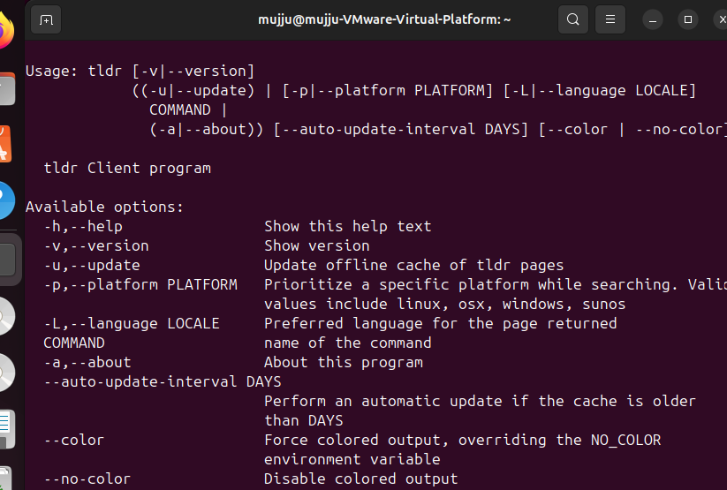

Essential File Management Tools Commands :
ls/home/mujju – to see the list of files in different directories by using a single command
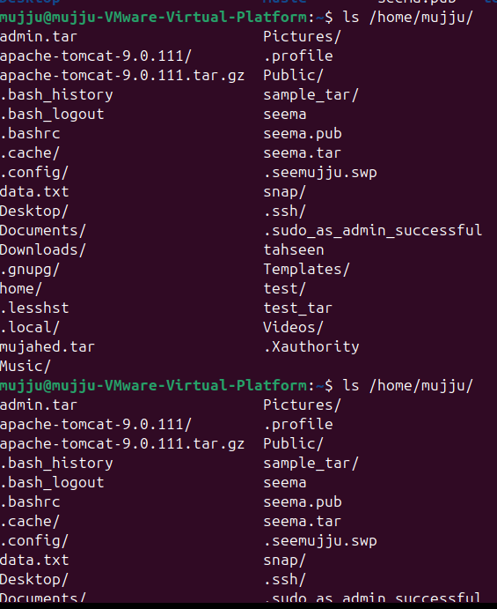
Cp – to copy a file from one location to other
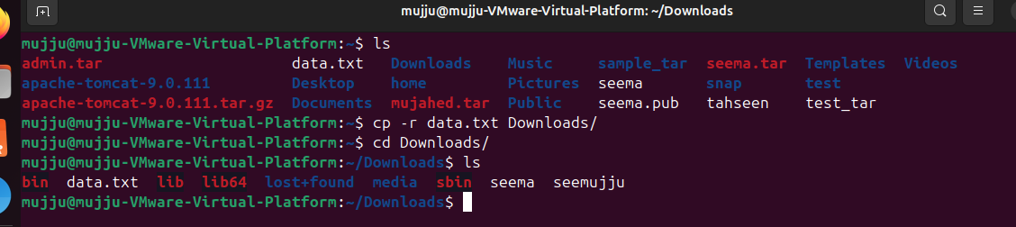
mkdir – to create a new directory
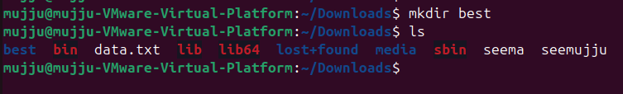

rmdir – to delete an empty file
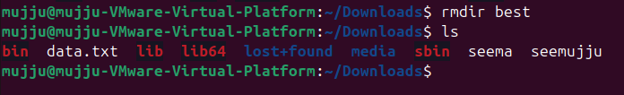

mv command to move file from one location to another
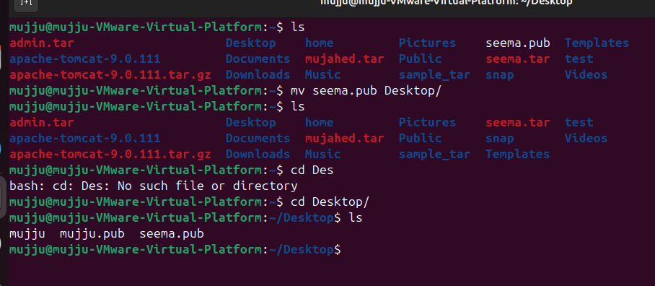

rm to delete a file
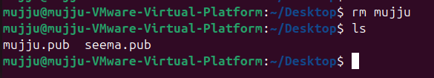

Advanced File Management Tools Commands:
ln -s to create a softlink to the directory
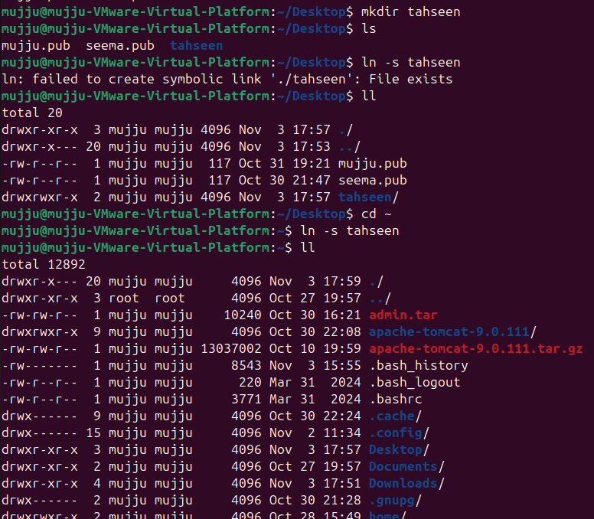
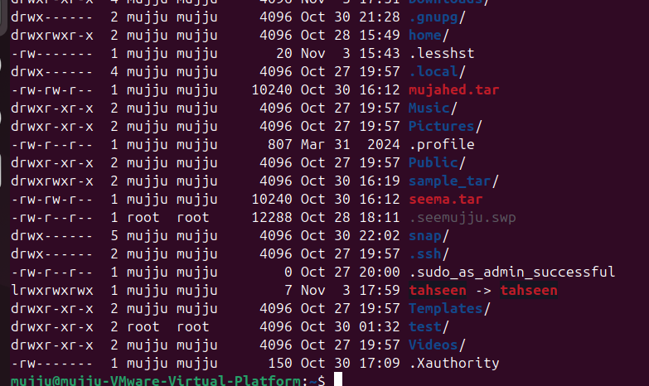
find command used to find files ,txt in given path

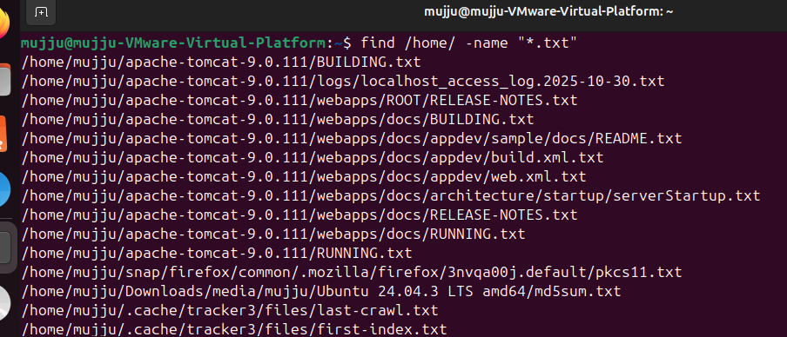

Locate command is used to locate a file in which directory is it present
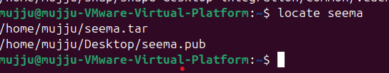
Which command will be Useful for finding executable files in system's PATH
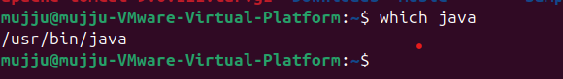
tar cvf command is used to compress the file
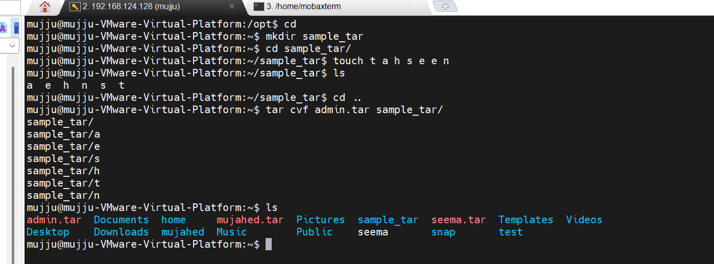

gzip command is used to compress the file where as bzip2 command is used to compress more
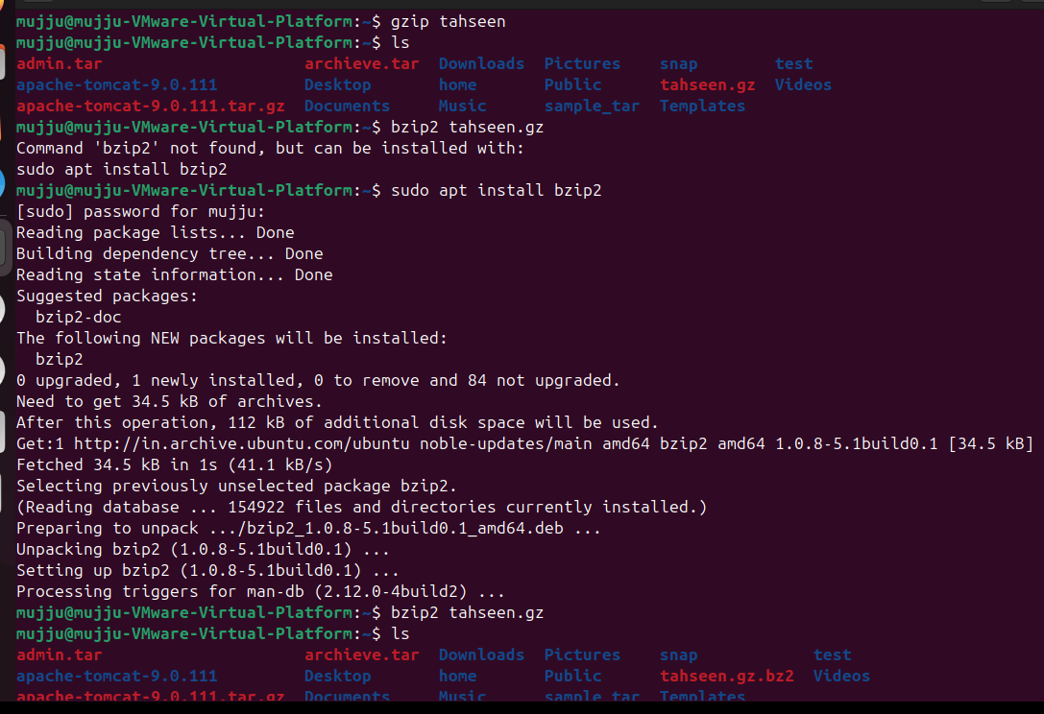

xz offers high compression utility
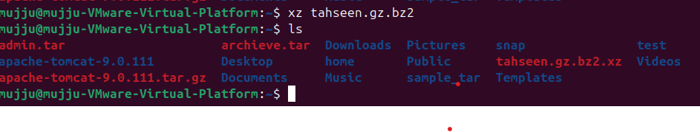

Zip and unzip commands used to compress and extract files
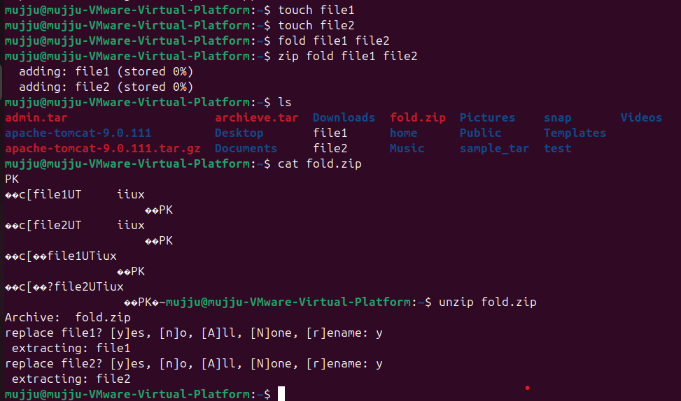

Mount – to expand storage or adding external drives
Lsblk : Lists information about block devices
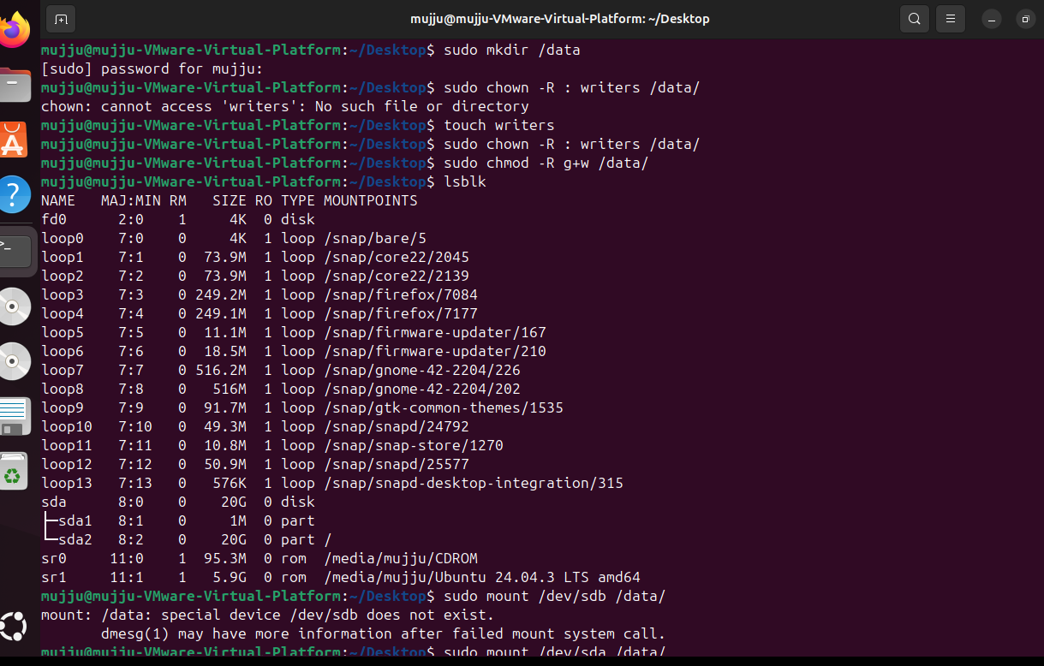

Findmnt – lists all mounted filesystems
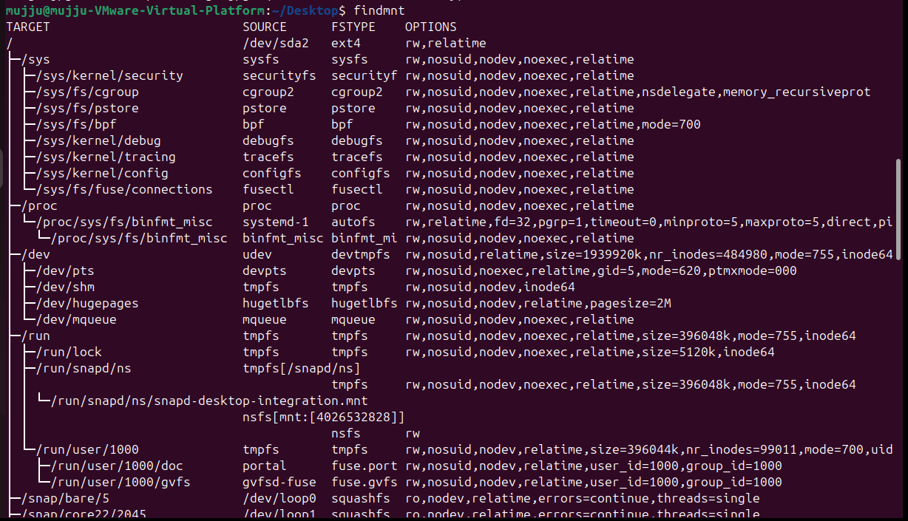
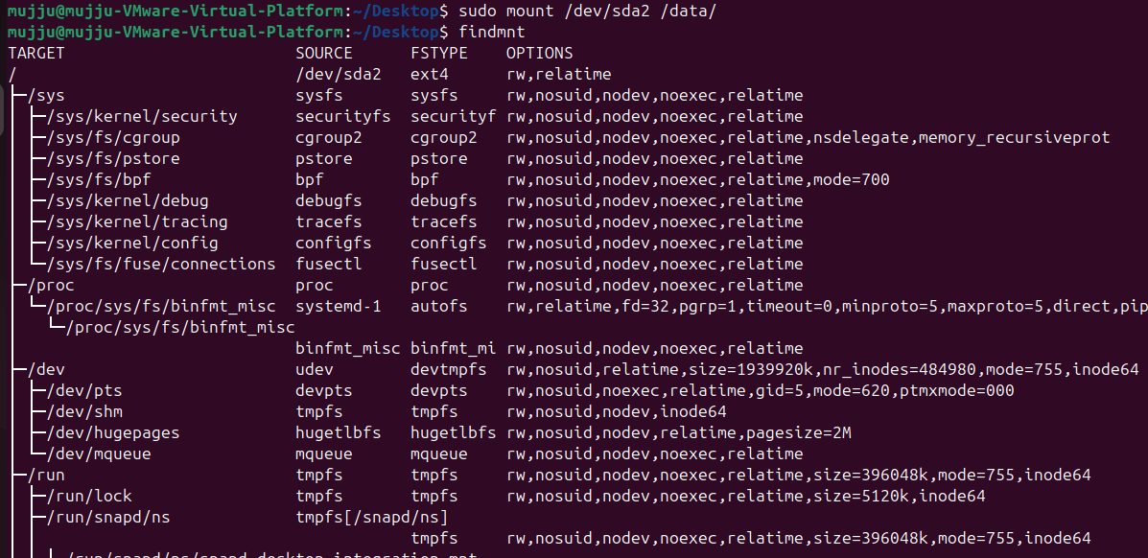

File command to check whether it is a text or image
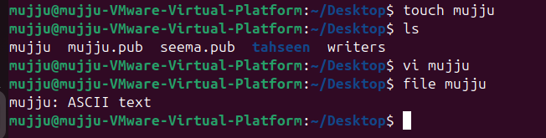
df - : Displays disk space usage of all mounted filesystems
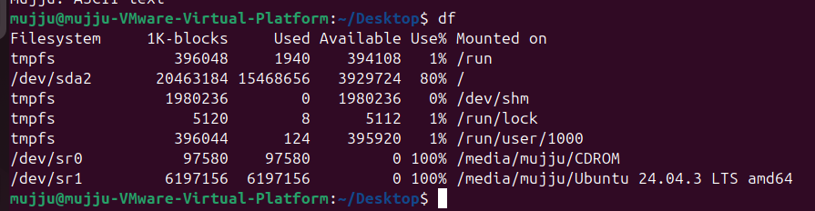

Working with Text Files Commands:

vi command is used to add the content in file
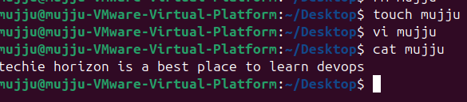
more command is used A pager to view the contents of text files, one screen at a time

less command is used to Similar to more, but provides more control over viewing text files.

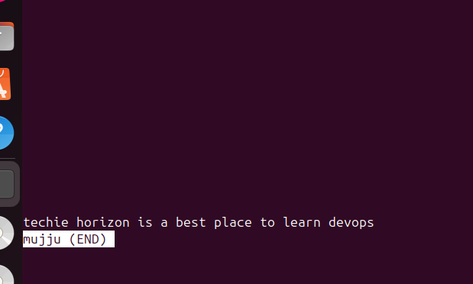

Head command is used to view the top lines of a file whereas tail command is used to view the last lines of a file
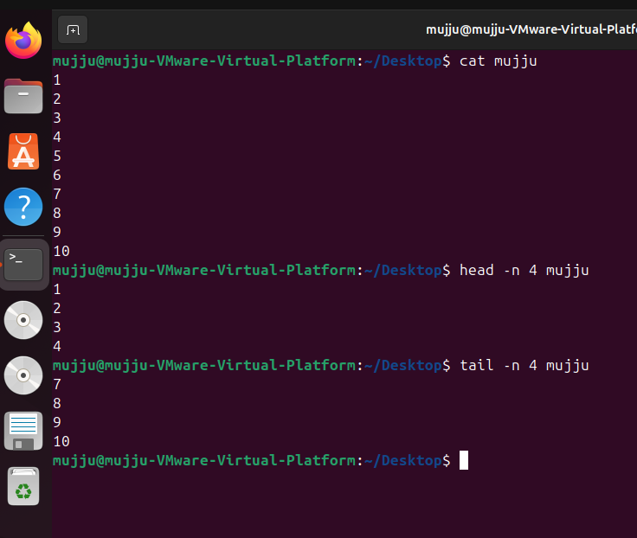
cat -A filename shows special charecters with content
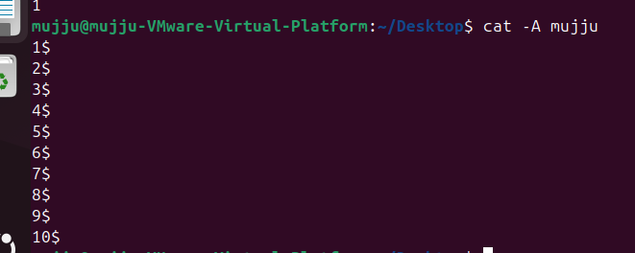
tac file name shows reverse order
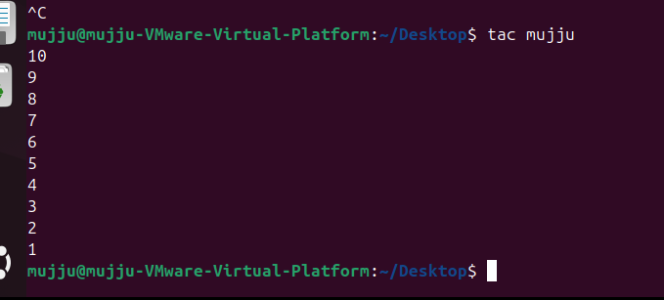
Advanced Text File Processing Commands:

Grep command is used to search a specific word in file
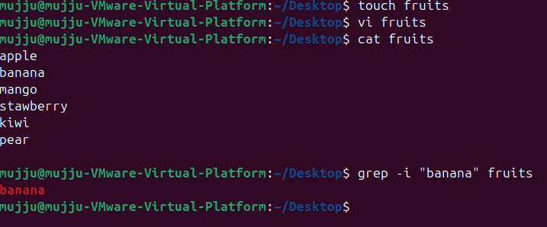
Sed command is used to replace word in file
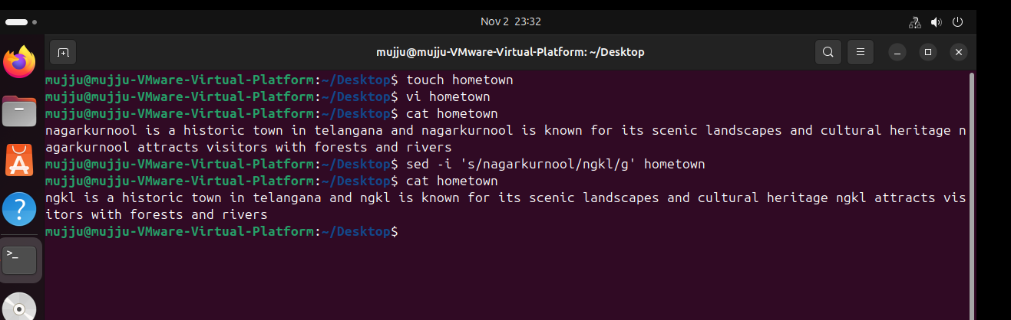

tr command is used to convert lowercase to uppercase and uppercase to lowercase
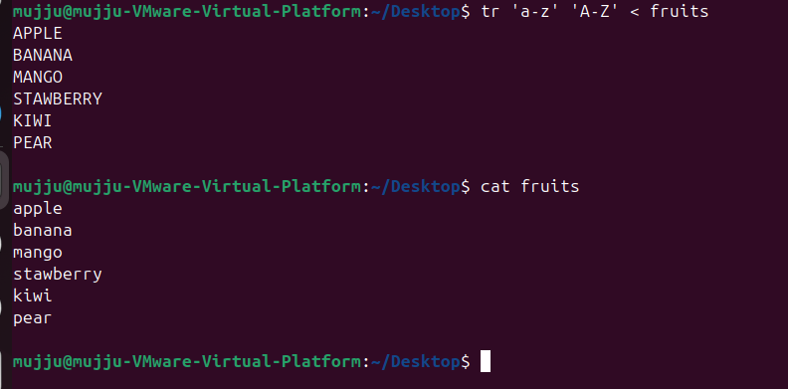

Sort command is used to get the file in numeric and alphabetical order
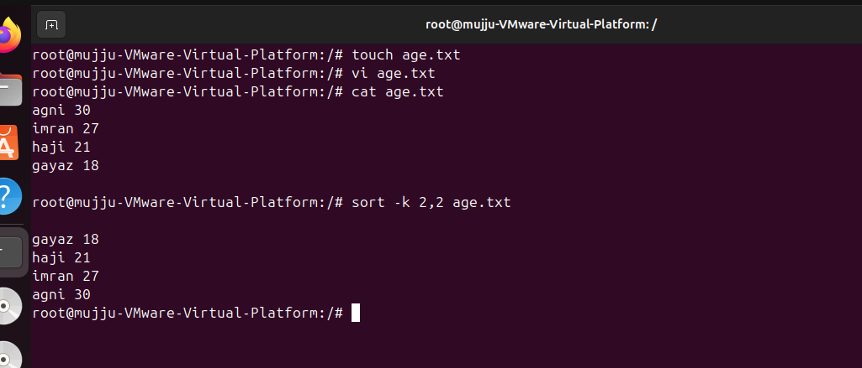

Cut command is used to Extracts sections from each line of files
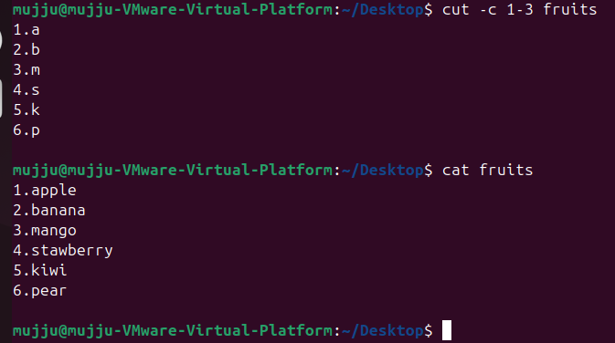

Sudo command is used to get extra privileges whereas su command is used to switch user
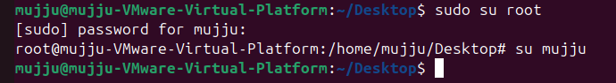

Ssh command is used connect to remote server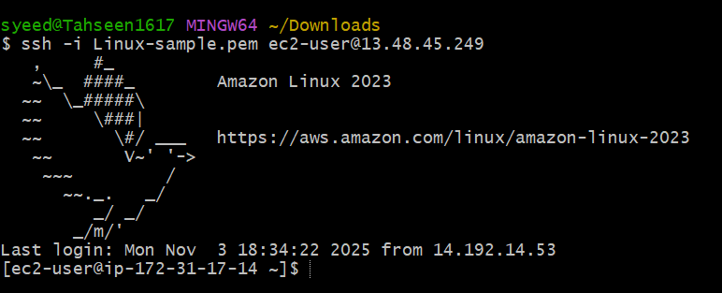

Scp command is used to copy file from windows to linux and from linux to windows
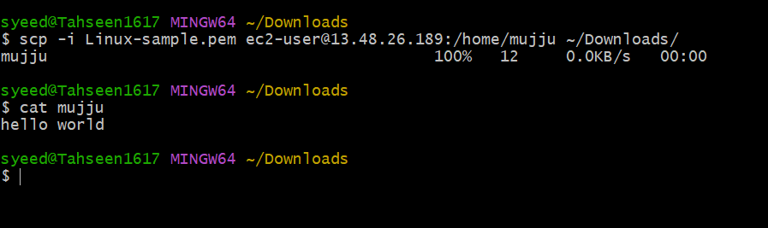

Working with the Bash Shell commands
tee command in Linux is used to split the output of another command so that it can be seen on the screen and saved to a file at the same time
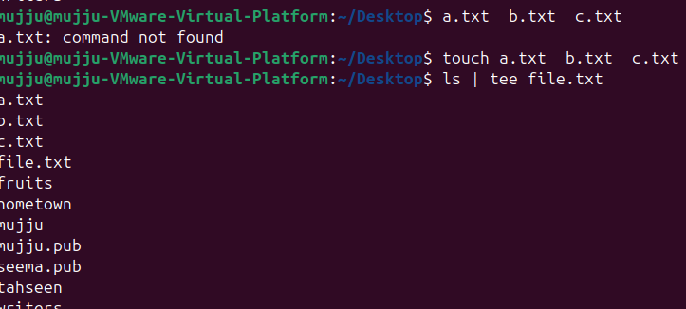

History command is used to see history of commands which have been executed
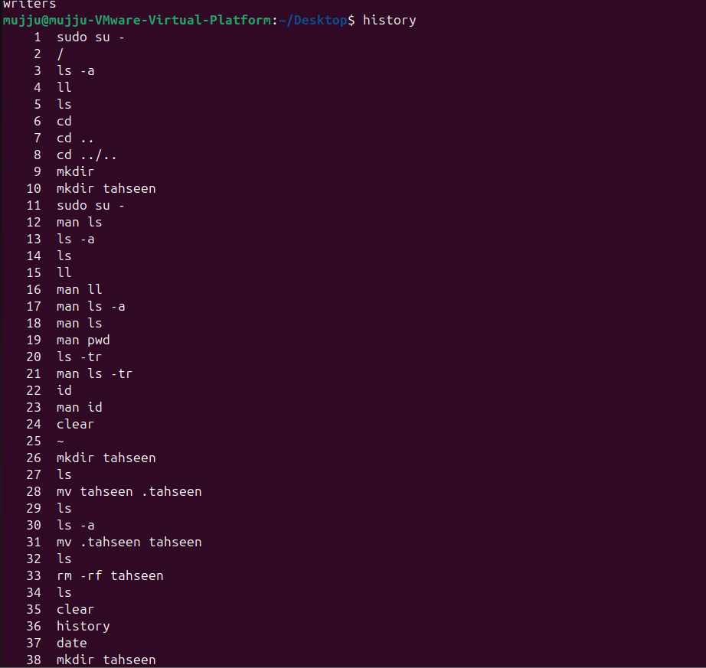

Alias command is used to create a shorter for longer command
